1. create users called itiuser1, itiuser2

sudo useradd -m itiuser1

sudo useradd -m itiuser2

ls /home

2. create group called os_team

sudo groupadd os_team

3. create directory called os_team_workspace

mkdir os_team_workspace

4. assign os_team group to the directory os_team_workspaceand change mode to setgid (hint use sudo)

sudo chgrp os_team os_team_workspace

ls -ld

chmod g+s os_team_workspace

5. add users itituser1 and itituser2 to os_teamgroup

sudo usermod -a -G os_team itiuser1

sudo usermod -a -G os_team itiuser2

groups itiuser1

groups itiuser2

6. create directory mydir1 using itiuser1 and mydir2 using itiuser2

sudo passwd itiuser1

sudo passwd itiuser2

cd /var

ls

su itiuser1

sudo mkdir mydir1

ls

su itiuser1

sudo mkdir mydir1

ls

7. list directory permissions and send screenshot

ls -l

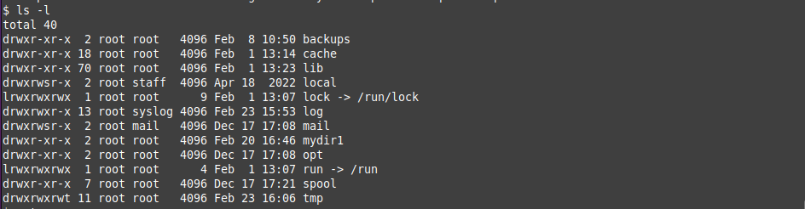

8. send screenshot of all processes in tree mod

pstree

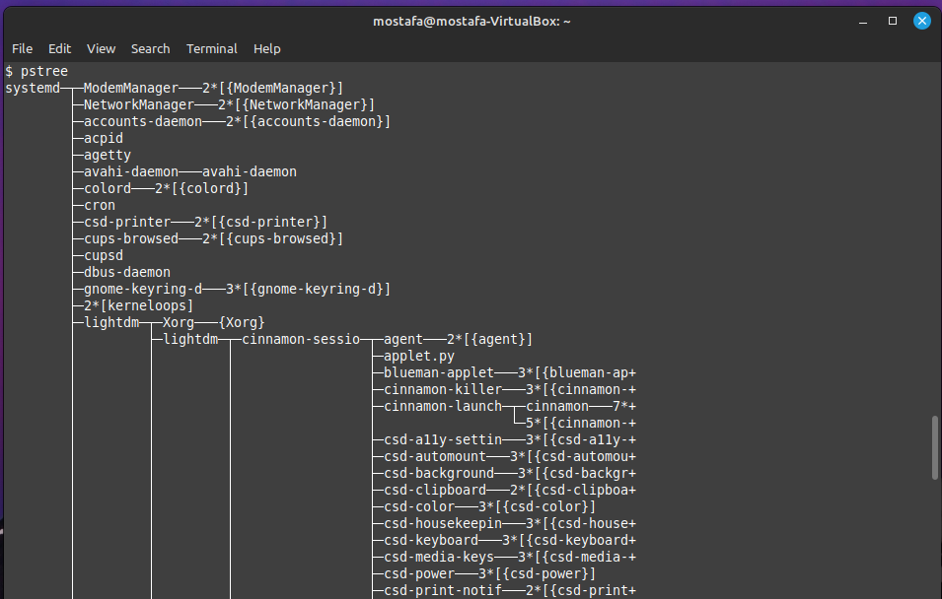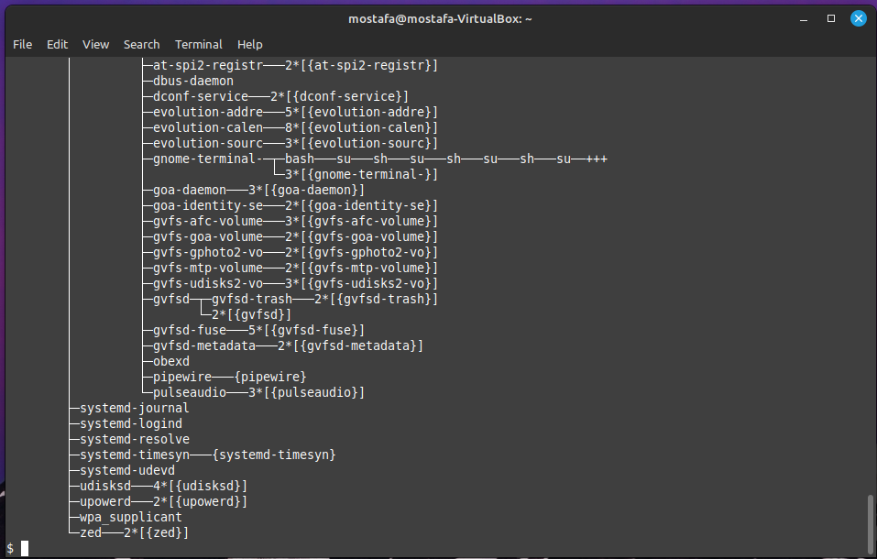

9. execute command tail -f /var/log/syslog

su mostafa

tail -f /var/log/syslog

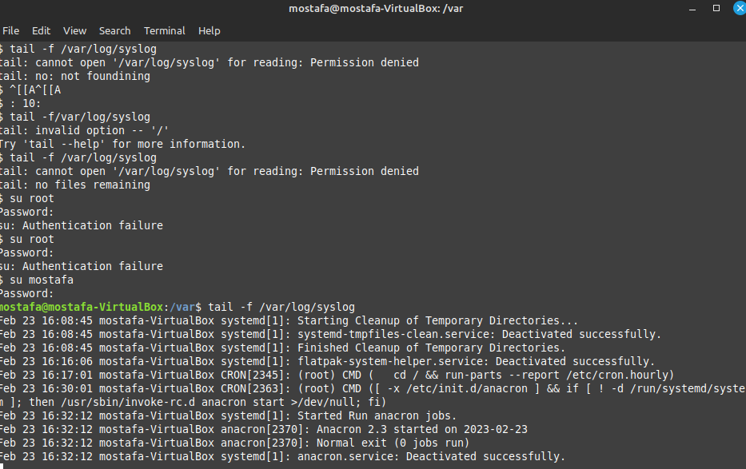

10.find the process id PID of tail process then kill it using kill command

ps -aux

kill -9 2378